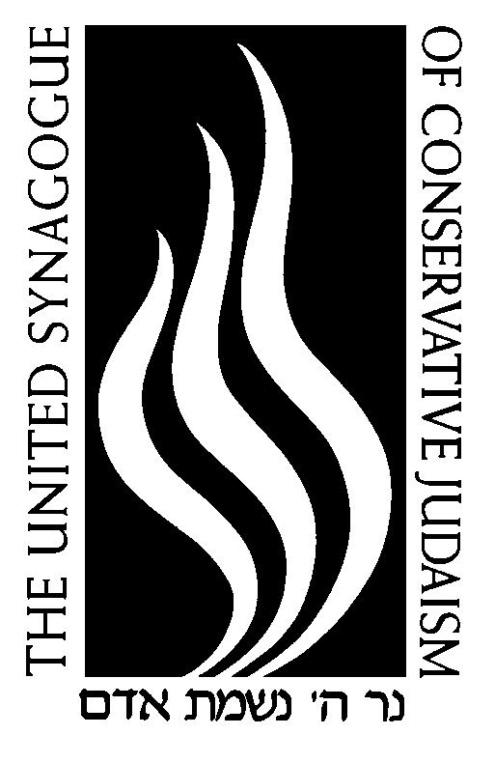

USY PROGRAM ASSOCIATE

United Synagogue of Conservative Judaism

Mission Critical Yes

Position Purpose

USY (United Synagogue Youth) is the youth organization of the United Synagogue of Conservative Judaism. With regions throughout North America, USY offers chapter, regional and international events, engaging thousands of teenagers. The program associate will work in conjunction with part-time advisors and youth directors on the chapter levels, regional youth directors across the continent and full-time staff in the international USY office. The program associate will focus on spearheading leadership development, Tikun Olam (USY’s tzedakah program) and support of USY summer programs.

Duties and Responsibilities

- Manage parent communications for Leadership Training using Constant Contact and RegPack
- Coordinate registration materials and coordinate collections of outstanding documents and fees for programs including AIPAC, Schusterman HS Summit and board weekends.
- Direct conference logistics with USCJ Operations department including confirmation of lodging, catering calls and sightseeing for USY on Wheels.
- Manage scholarship through FACTS and upload information or regional directors
- Work with CampMeds and medical liaison for summer program participants
- Work with the Communications department to send out recruitment information through Constant Contact as well as curate the USY website in coordination with the communications department
- Play lead role in overseeing the Tikun Olam program, including tracking contributions from chapters and regions.
- Develop relationships with recipient and curating the list of said agencies

Work Environment

This job operates in a professional office environment. This role routinely uses standard office equipment such as computer, phones, filling cabinets and other office equipment.

Physical Demands

The physical demands described here are representative of those that must be met by an employee to successfully perform the essential functions of this job.
While performing the duties of this job, the employee is regularly required to talk or hear. The employee is frequently required to stand; walk; use hands to handle or feel; and reach with hands and arms.

Position Type/Expected Hours of Work

This is a full-time position exempt from overtime. Days and hours of work are Monday through Friday, 9:00am to 5pm.

Knowledge and Skills

Proficiency in Microsoft office, particularly Excel
Attention to detail, proofreading and editing
Knowledge of Conservative Jewish practice
Background in Jewish education
Some recruitment, travel including international and regional USY events
Ability to work with others on a collaborative team
Ability to learn RegPack (our registration system)

Education and Work Experience

BA degree

